Feature Extraction 12.0.3.2 Windows 10 Installation Note (supplemental)

In some cases, upon completion of the installation, the FE installer will not display the “completed installation” window and will remain in the “installing” window. A visual inspection of the installer window will show that status bar has nearly reached the end, but the installer window has not changed to “completed installation” and allow you to “close” the window.

To complete the installation and close the installation program, you will need to execute the follow steps.

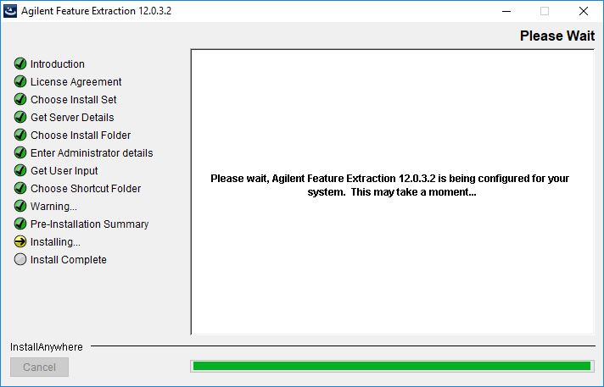

- To insure a successful installation, wait one additional minute to insure the installation has completed.

Note: Closing the installation windows too soon will leave Feature Extraction incorrectly installed.

- Close the installation application by, Clicking the “X” in the upper right-hand corner of the window.
- Select “Quit” button to close the installation window and finish the installation.

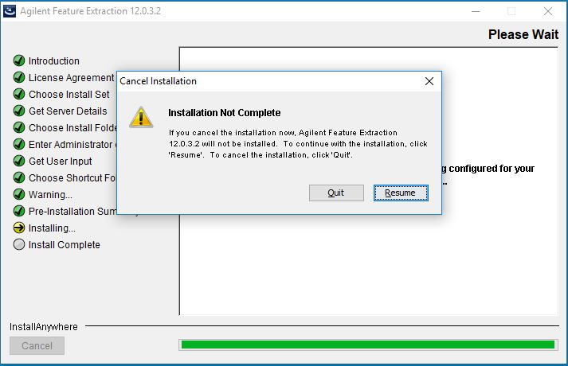
Note: Closing the installation application using methods other than clicking “X” will cause a failure of the normal uninstall process for FE.
Step 3: “Click Quit” to the installer
Step 2: “Click X” to close the window

