Agilent Product Name: Molybdenum Standard: 1000 µg/g Mo in 75 cSt Hydrocarbon Oil
Agilent Part No: 5190-8767
Lot No: 000968064E

Product Specifications

Analyte | Starting Material | CAS # | Matrix | Certified Concentration
Mo | Proprietary | n/a | 75 cSt Hydrocarbon Oil | 1000 ± 10 µg/g

Intended Use: This solution is intended for use as a certified reference material or calibration standard for the analysis of this element in petroleum products or other organic matrices using inductively coupled plasma optical emission spectroscopy (ICP-OES), inductively coupled plasma mass spectrometry (ICP-MS), atomic absorption spectroscopy (flame AAS or GFAAS), microwave plasma atomic emission spectroscopy (MP-AES), rotating disc electrode atomic emission spectroscopy (RDE-AES), and other techniques for elemental analysis.

Certification & Traceability: This CRM was manufactured under a quality management system that is accredited to ISO Guide 34, ISO/IEC 17025, and registered to ISO 9001. This CRM was prepared to the certified concentration shown above by gravimetric methods using a single-element concentrate that is traceable to the NIST SRM listed below. The balances used in the preparation of this CRM are calibrated regularly with traceability to NIST. The certified concentration was determined based upon gravimetric procedures. Secondary verification of the certified concentration was performed using ICP-OES and these data are traceable to NIST SRM 3134. The uncertainty associated with the certified concentration represents the expanded uncertainty at the 95% confidence level using a coverage factor of k=2.

Uncertified Values: ICP-OES was used to determine trace metal concentrations for this product (nd = not determined).
Trace Concentrations (µg/g)
Ag | <1 |  | Co | <1 |  | Mn | <1 |  | Si | <1
Al | <1 |  | Cr | <1 |  | Mo | Major |  | Sn | <1
As | <1 |  | Cu | <1 |  | Na | 0.1 |  | Sr | <1
B | <1 |  | Fe | <1 |  | Ni | <1 |  | Ti | <1
Ba | <1 |  | Hg | <1 |  | P | <1 |  | Tl | <1
Be | <1 |  | K | <1 |  | Pb | <1 |  | V | <1
Bi | <1 |  | La | <1 |  | Sb | <1 |  | Y | <1
Ca | <1 |  | Li | <1 |  | Sc | <1 |  | Zn | <1
Cd | <1 |  | Mg | <1 |  | Se | <1 |  | Zr | <1

Instructions for Use: Agilent Technologies recommends that the solution be thoroughly mixed by repeated shaking or swirling of the bottle immediately prior to use. To achieve the highest accuracy the analyst should: (1) use only pre-cleaned containers and transferware, (2) avoid pipetting directly from the CRM’s original container, (3) use a minimum sub-sample size of 500 mg, (4) make dilutions using calibrated balances or certified volumetric class A flasks and pipettes, (5) dilute to volume or weight with the same matrix as the original CRM, and (6) never pour used product back into the original container. Fresh solutions should be prepared daily. The solution should be kept tightly capped. Store at controlled room temperature per USP 35 (10.30.60). Do not freeze, heat, or expose to direct sunlight. Minimize exposure to moisture or high humidity.

Period of Validity: Agilent Technologies ensures the accuracy of this solution until the expiration date shown below, provided the instructions for use are followed. During the period of validity, the purchaser will be notified if this product is recalled due to any significant changes in the stability of the solution.

 | Sample lot approver:
Date of release: 26 February 2016 | 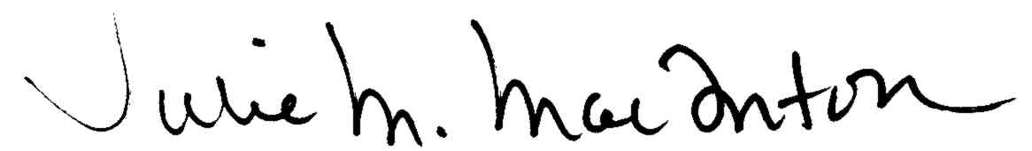
Date of expiration: 10 March 2017 | QA Manager

